Jesse Renteria & Emmanuel Maqueda
4/22/2025
CSCI413
Weather Predictions
- Background
When looking at the datasets, a system is created to look for specific variables that are important to predict the weather. Here an analysis was performed for both the greenhouse gases of the data as well as looking into further depth of our changing climate. This project will be using 5 years’ worth of past data for the states that have been selected. For this, an equation must be generated that will give our prediction more accuracy and precision. Using data preprocessing to ensure what the dataset for climate change is looking like. As for greenhouse gas emissions, it contributes heavily when it comes to the sudden changes in climate. According to the European Parliament, yearly there is a 2.5% increase in emissions that are causing more natural disasters and irrational temperature changes during seasons that are not meant to be causing such changes [1]. The hope is that around 55% of greenhouse gas emissions are controlled by renewable energy and other forms of renewable technologies to better the environment and climate changes [1]. When looking at the changes in temperature, it has been raised .13 C (¼ F) in the last 50 years [2]. With this information we can begin to understand how much the temperature across the world has increased and give a rough estimate on how this could also be affected when it comes to greenhouse emissions. Since we have seen a 2.5% yearly increase in greenhouse gases, we can assume that the temperature change will also increase. It was predicted in 2015 that it would be .2 C higher per decade in 20 years [2]. Hence knowing this and more information that since 1880, the temperature has risen by 1.1 C (1.9 F) since 2023 [3]. As of now the estimate is changing drastically making it difficult to calculate a value that is precise enough to fit our highest accuracy. Thus, being able to use information from the EPA, the average decrease in greenhouse gases has currently dropped by 17% as of 2023 [4] [5]. With this information, a model can be created that gives a rough estimate of how much percent of Greenhouse gases are reduced by the day or year and the areas most affected by greenhouse gases.
- Abstract
This project aims to create a model that can predict temperature, renewable energy, and emissions in any location of the U.S. using meteorological data from five different regions of the U.S.: Northeast, Southeast, Southwest, Midwest, and West accessed from OpenMeteo, Kaggle, and the EPA. The five states - New Jersey, Florida, Texas, Michigan, and California - were selected to represent each region, respectively, with an additional state, Colorado, to help improve the predictions. The first step of the study was making a request to OpenWeather to access the daily weather dataset from these different states in a span of five years, grouping them all together and turning it into a Data Frame object using the pandas library. Secondly, the information was read through thoroughly to see if there are any null values and the datatypes each feature had. Only to realize that there were many missing values on one column called Snow and the solution to this issue was to fill the null values with 0 indicating there was no snow and convert the actual value, “T”, into a 1 indicating there was snow. Many technical difficulties occurred from features having multiple features inside that stored values that would be essential in predicting temperature and the solution was handled by running a for loop that accessed the feature and taking the features inside and storing it into new features, creating new columns to the dataset. When handling the categorical features, the get_dummies() function was used to turn them into Booleans, while the continuous numerical features were standardized using the StandardScaler() function for consistent training to ensure that the model is not biased towards features with larger scales. The last step of the Preprocessing was to split the dataset into training and testing sets to evaluate our model’s performance using the train_test_split() function.
- Data Collection
A new dataset that was researched is between the global greenhouse gases being released into the atmosphere and the renewable energy in different countries. When it comes to greenhouse gases, we understand that it will be one of the primary factors that contribute to the temperature of the earth and the location of which someone is in. Thus, having a record of the emissions per unit of each major plant in the U.S is helpful to get a better understanding of how much some locations across the U.S differ from each other. Furthermore, if we are going to incorporate greenhouse emissions into our final equation, we need to also include what the world is doing to prevent more greenhouse gases into the atmosphere. Hence looking at the households across the world is important because we can select North America and observe the different types and amount of energy that is produced to have an advantage over other options that are currently damaging the environment such as gas and fossil fuels.
- Data Preprocessing
For the data processing of the greenhouse gases, our team initially used API calls to collect datasets from sources related to greenhouse gases. However, upon closer inspection, many empty values were inside the dataset, and our team could not use a dataset with many empty values. Thus, our team searched for an alternative and found massive dataset and exported the file as an excel file that was converted into a CSV file that was in UTF-8 Unicode. The main reason for this conversion was because it was the only way it would appear and would be accessible to open in a Jupyter notebook. Furthermore, most of these files were merged since they contained similar locations but simply needed adding the fuel amount and gas emissions for each location. The next objective was to check for null values; since the dataset contains IDs and undetermined values, a 0 or N/A was imputed into the cell to keep everything understood. Then, for the Kaggle dataset, it was simple since everything was much more organized only needing to do the summary tests and being able to see the issues that could be important. The ‘get_dummies()’ function call and other libraries were used to assist in completing our data preprocessing and analysis. As we noticed from our greenhouse data, there are multiple trends where some do not report the amount they released into the atmosphere while some have values for different fuel or gas types. Some of this is going to need to be either divided to observe at different levels or will be all just one sum of greenhouse gases across the U.S.
- Exploratory Data Analysis
During the Exploratory Data Analysis (EDA), many observations were made looking at the relationship between temperature and the rest of features in scatter plots and a correlation matrix using the matplotlib, Scikit-learn and seaborn libraries. In the Colorado Dataset, temperature had an average of 47.829 degrees Fahrenheit, with a standard deviation of 8.729 degrees Fahrenheit and a median of 41.47 degrees, pressure had an average of 1000.325 hPa with a standard deviation of 8.57 hPa and a median of 1001.5 hPa , humidity had an average of 26.475 % with a standard deviation of 10.824 and a median of 24.5, and wind speed had an average of 11.3305 mph with a standard deviation of 5.625 mph and a median of 10.58 mph. In the New Jersey Dataset, temperature had an average of 51.564 degrees Fahrenheit with a standard deviation of 9.468 degrees Fahrenheit and a median of 49.39 degrees Fahrenheit, pressure had an average of 1014.975 hPa with a standard deviation of 4.9172 hPa and a median of 1017 hPa, humidity had an average of 71.35 % with a standard deviation of 15.997 % and a median of 75.50 %, and wind speed had an average of 10.356 mph with a standard deviation of 4.566 mph and a median of 9.225 mph. In the Florida Dataset, temperature had an average of 64.6237 degrees Fahrenheit with a standard deviation of 8.493 degrees Fahrenheit and a median of 64.715 degrees Fahrenheit, pressure had an average of 1015.25 hPa with a standard deviation of 5.934 hPa and a median of 1014.5 hPa, humidity had an average of 67.575 % with a standard deviation of 23.192 % and a median of 65.5 %, and wind speed had an average of 7.9737 mph with a standard deviation of 3.9122 mph and a median of 7.65 mph. In the Texas Dataset, temperature had an average of 68.049 degrees Fahrenheit with a standard deviation of 7.171 degrees Fahrenheit and a median of 67.675 degrees Fahrenheit, pressure had an average of 1007.55 hPa with a standard deviation of 8.7792 hPa and a median of 1006 hPa, humidity had an average of 29.35% with a standard deviation of 11.647 % and a median of 28 %, and wind speed had an average of 10.679 mph with a standard deviation of 5.330 mph and a median of 9.14 mph. In the Michigan Dataset, temperature had an average of 46.324 degrees Fahrenheit with a standard deviation of 12.272 degrees Fahrenheit and a median of 43.845 degrees Fahrenheit, pressure had an average of 1005.625 hPa with a standard deviation of 10.134 hPa and a median of 1010 hPa, humidity had an average of 63.9% with a standard deviation of 14.179% and a median of 63 %, and wind speed had an average of 12.51 mph with a standard deviation of 5.81 mph and a median of 12.01 mph. In the California Dataset, temperature had an average of 54.684 degrees Fahrenheit with a standard deviation of 6.052 degrees Fahrenheit and a median of 55.125 degrees Fahrenheit, pressure had an average of 1016.075 hPa with a standard deviation of 2.912 hPa and a median of 1017 hPa, humidity had an average of 54.975% with a standard deviation of 17.118% and a median of 51%, and wind speed had an average of 6.795 mph with a standard deviation of 5.857 mph and a median of 4.765 mph. Once all the datasets were all combined, a correlation matrix was made to look at the correlation between temperature and its other features. The most notable part was that temperature had the high correlations with pressure, humidity, sea level, ground level, and wind degrees and there were a few issues with multicollinearity with feel-like temperatures which would mean that feel-like temperatures would have to be removed from the model to create an accurate and reliable regression model.
For this section of the data project, the number of states needed to be reduced since it is troubling to mess with a large amount of data at the same time. The states we are covering are Colorado, California, New Jersey, Texas, Florida and Michigan as they are nicely spread out in the U.S available to be analyzed in different environments. Initially, we thought of training our datasets using linear regression and polynomial regression but ultimately decided to use Random Forest trees since it would be able to reiterate and analyze the different types of data. Before training our data, a correlation matrix was made to see the variables that had the most correlation to have a better model. Below is the correlation matrix and how our data looked before doing any training with random forest trees. The same method was implemented for the renewable and emissions data.
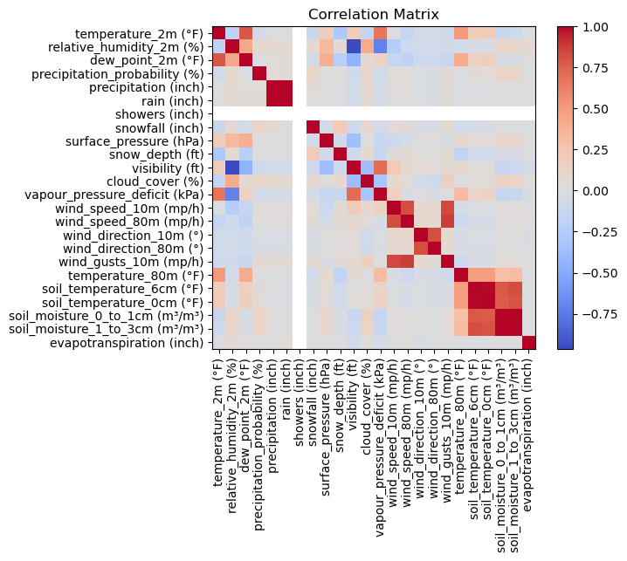

Figure 1: Correlation Matrix
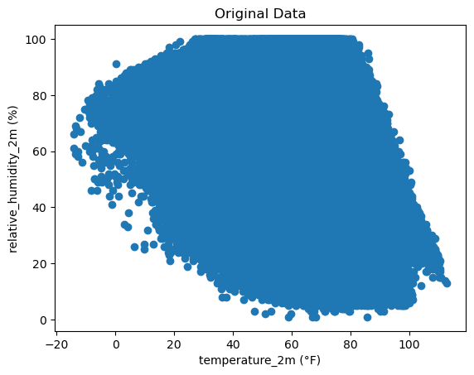  Figure 2: Temperature & Relative Humidity Scatterplot | 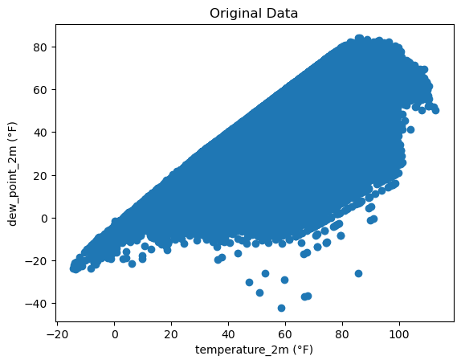  Figure 3: Temperature & Dew Point Scatterplot
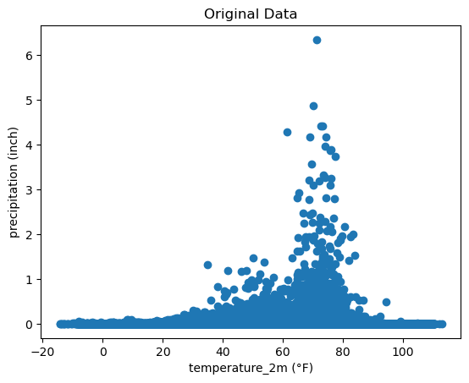  Figure 4: Temperature & Precipitation Scatterplot | 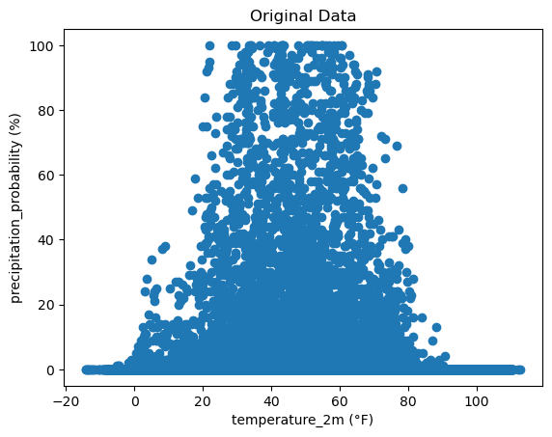  Figure 5: Temperature & Precipitation Probability Scatterplot
- Model Evaluations
After doing the initial random forest trees, for our weather data it had a .97 MAE which in our data is good and close to being almost a little error when it comes to predicting the temperatures of weather. Then, a second model was made using a machine learning technique called XGB Regression which basically ensures that it is using the proper features and at maximum capacity, resulting in a .96 MAE which is better since it got lower to 0 and shows to be more balanced. The reason being is that compared to the non-optimized random forest, we had a root mean square error of 1.41 compared to a 1.37 for the optimized model. Overall, this is a good success, meaning it will be cleaner to predict in the future.
When looking at our emission and energy datasets, we saw an original result of low MAE with 55850.25 metric tons for our CO2 emissions showing high promise when it came to optimizing the data. To get the data below, we used a long transformation as it would be the best fit for the model and, hence predicting. The reason we did not use any other form of data optimization or tuning is because the data was tuned with adding more iterations and also having a finer line when it came to figuring out the metric ton error.
- MAE: 219.99 metric tons
- Mean Actual Emissions: 63602.99 metric tons
- Error Percentage: 0.35%
Now we can look at the energy data we used to check out what we got as a result. Originally, we got 402.16 kWh as a MAE for the first random forest model. As for optimizing the data, we decided to go to GridSearch and XGBoost to see how it would affect the random forest. As a result:
- Optimized Model Performance:
  - MAE: 21.53 kWh
  - RMSE: 27.70 kWh
  - Mean Actual Usage: 748.33 kWh
  - Error Percentage: 2.88%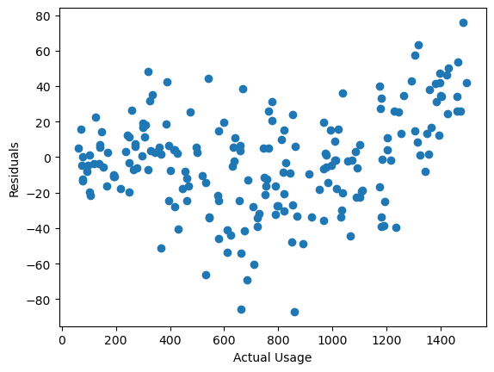
Figure 6: Residuals & Actual Usage Scatterplot
A much better error percentage as it is no longer a large error percentage when it comes to using the final equation to figure out the carbon emissions how emissions will not only increase but also seeing how much difference it will have when renewable energy removes most of those emissions.
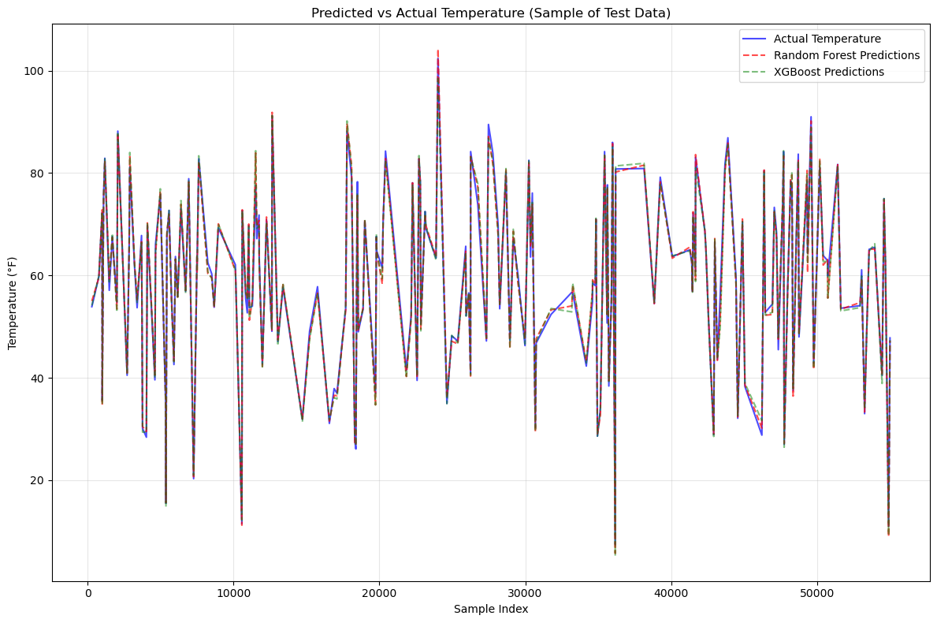
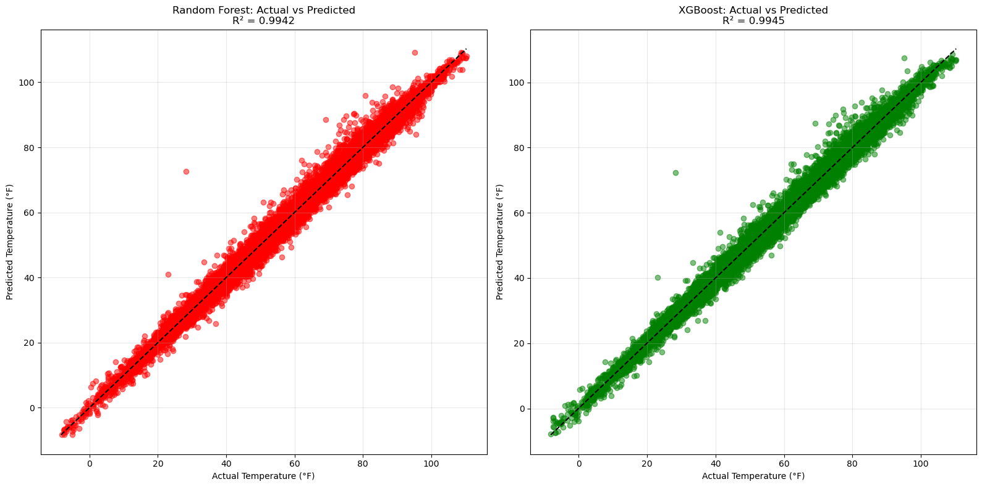
Figure 7: Predicted & Actual Temperature with the two models
Figure 8: Comparison of Predicted and Actual Temperature with the two models
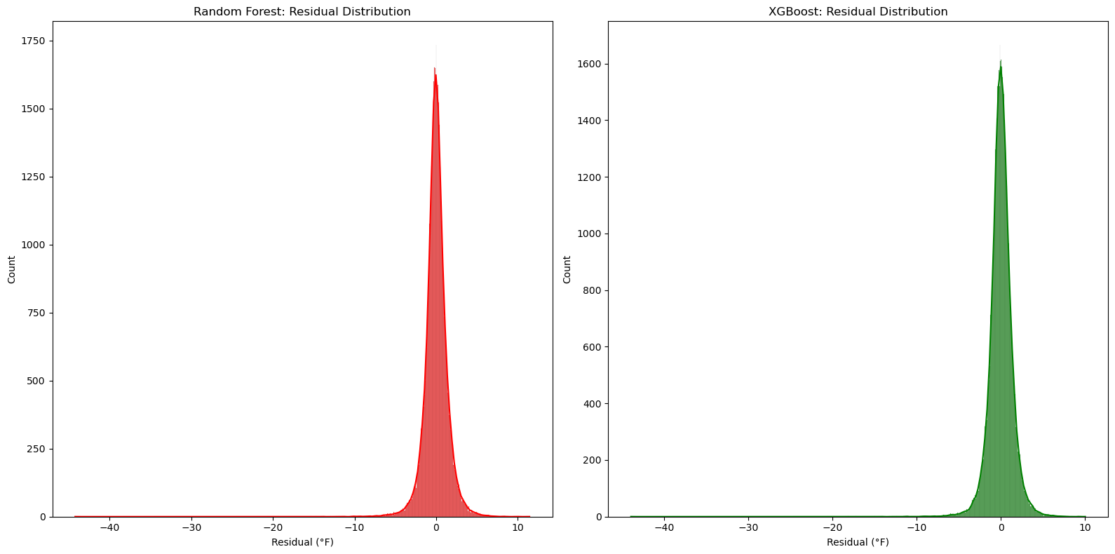
Figure 9: Comparison of Residual Distribution of the two models
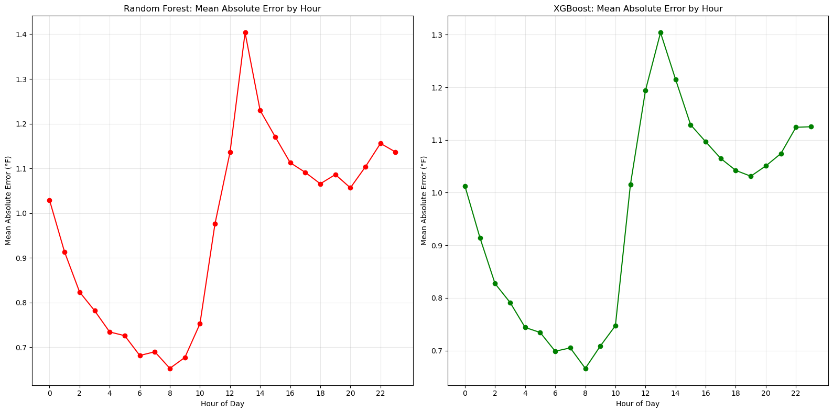
Figure 10: Comparison of Mean Absolute Error of the two models based on the hour of day
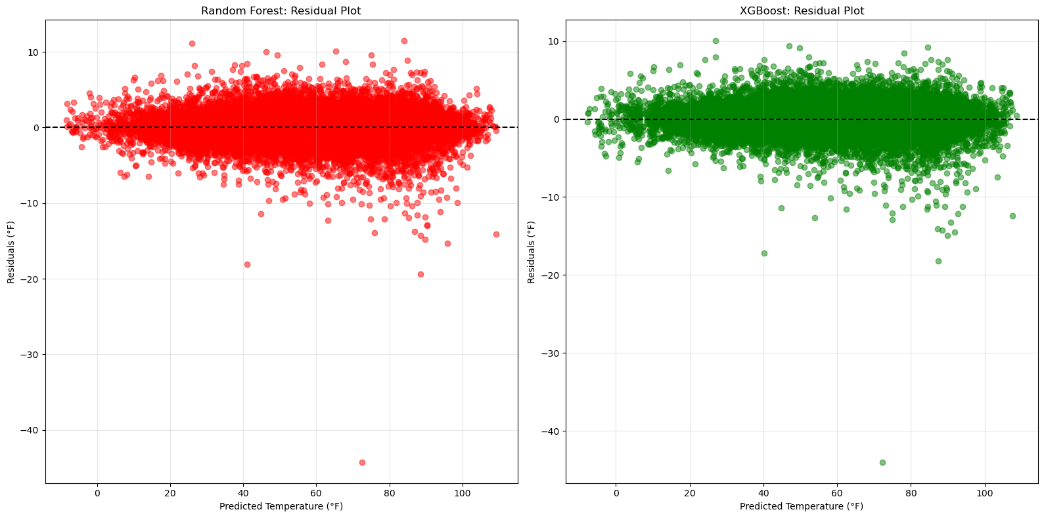
Figure 11: Comparison of Residual Plots of the two models
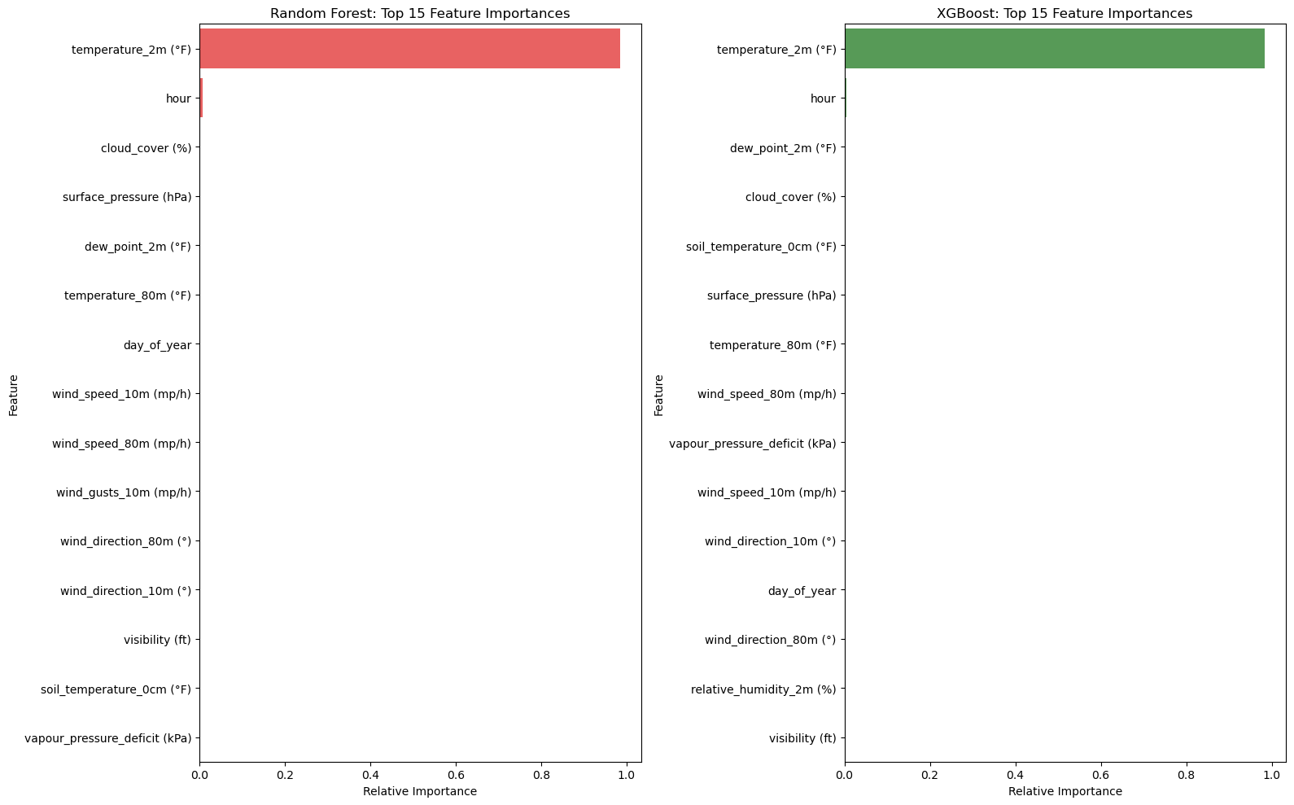
Figure 12: Comparison of Feature Importances of the two models
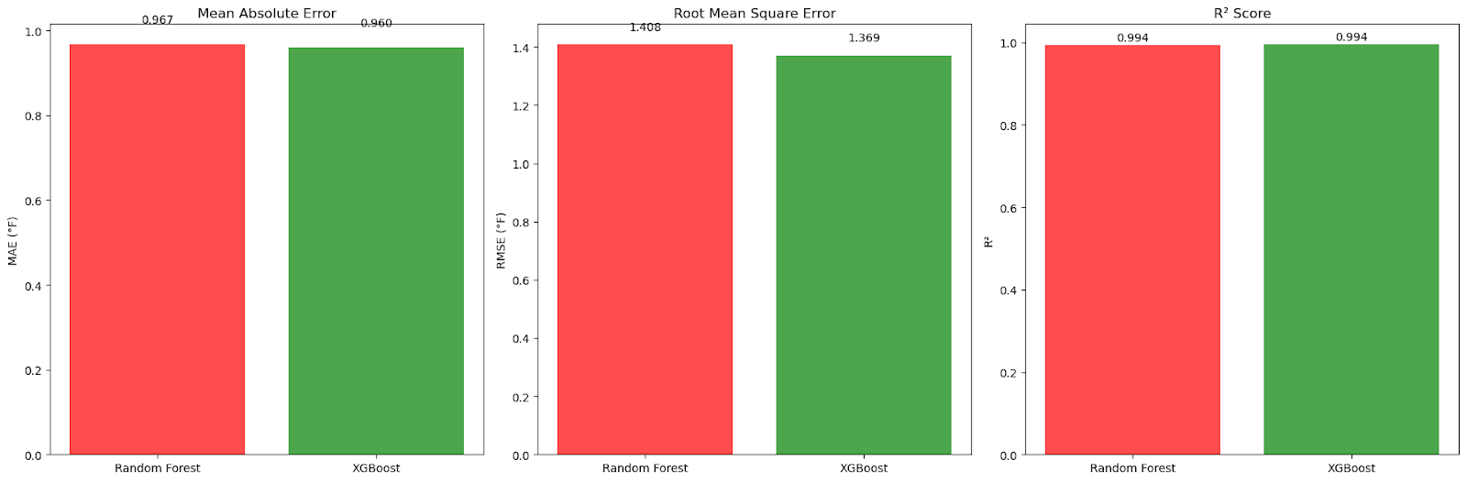
Figure 13: MAE, RMSE, R² Score Comparisons of the two models
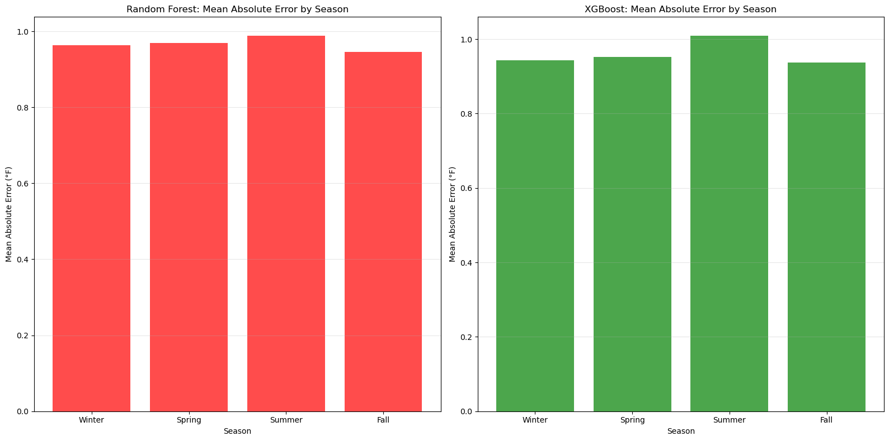
Figure 14: Mean Absolute Error Comparisons of the two models by season
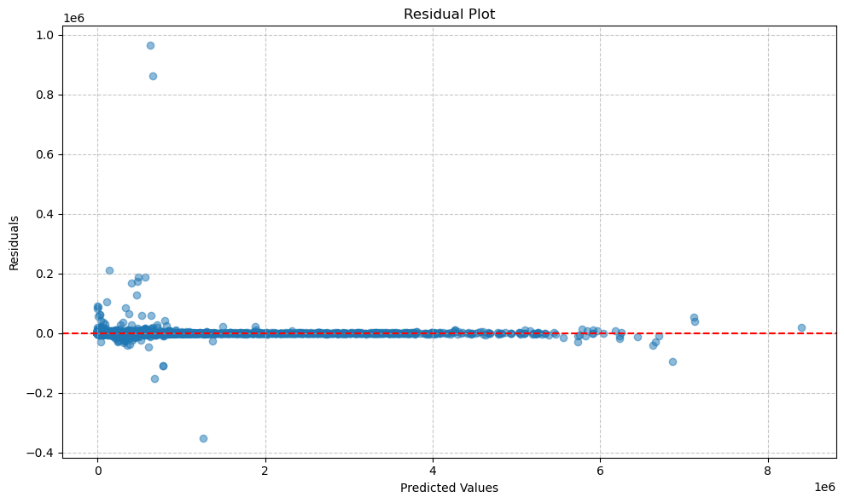
Figure 15: Residual Plot of the Emissions data
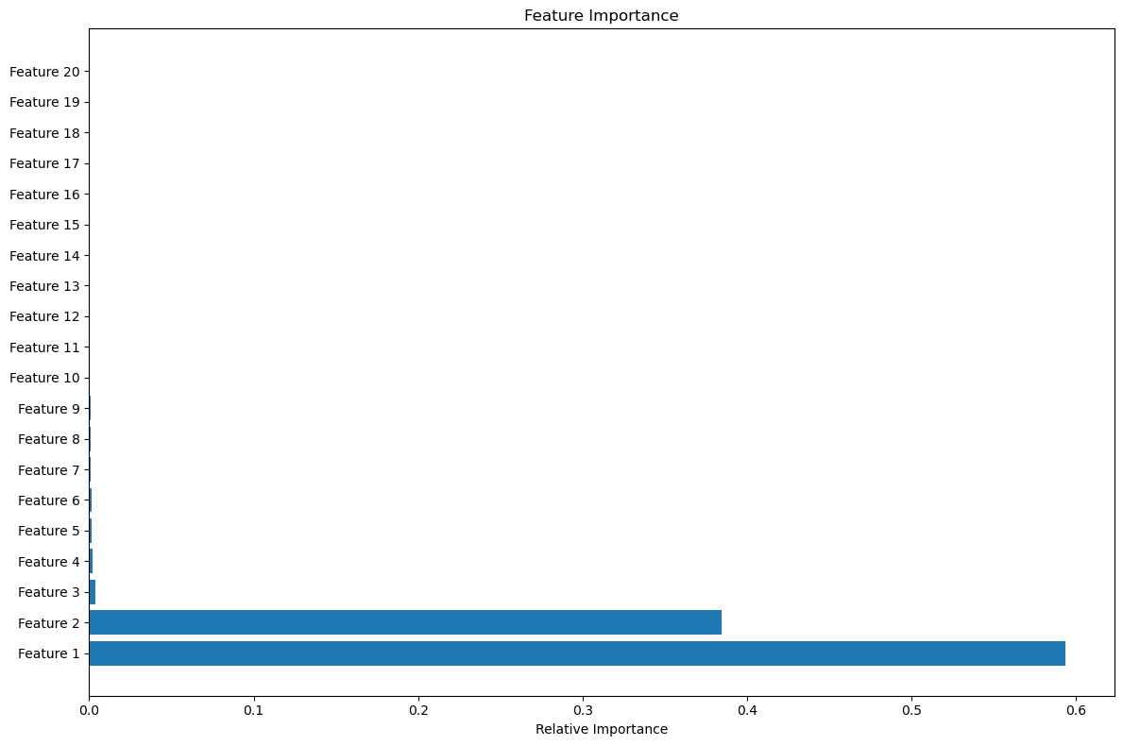
Figure 16: Feature Importance of the Emissions data
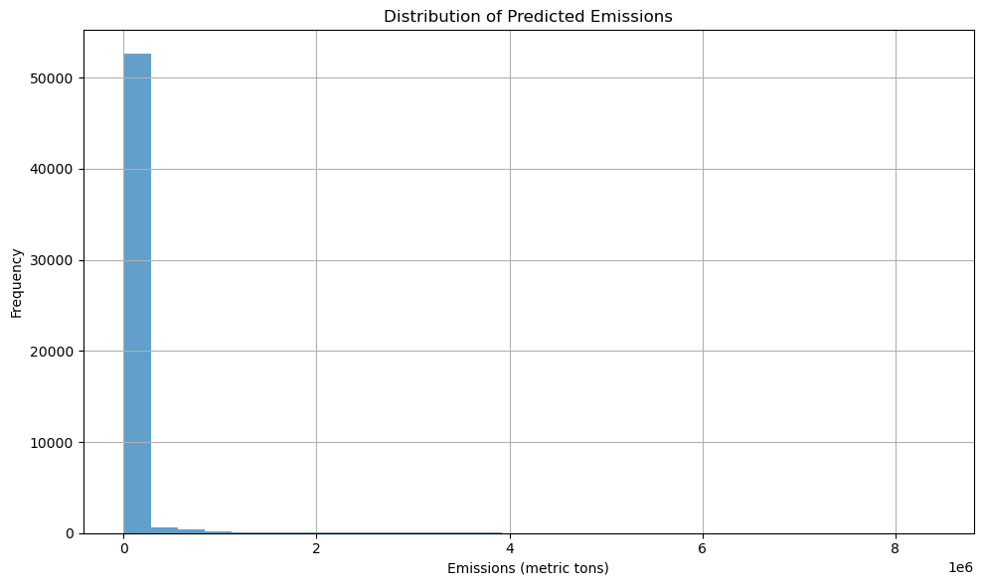
Figure 17: Distribution of Predicted Emissions
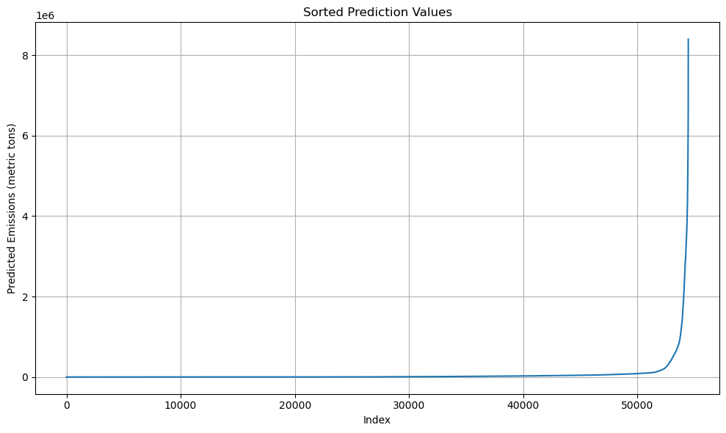
Figure 18: Sorted Prediction Emission Values
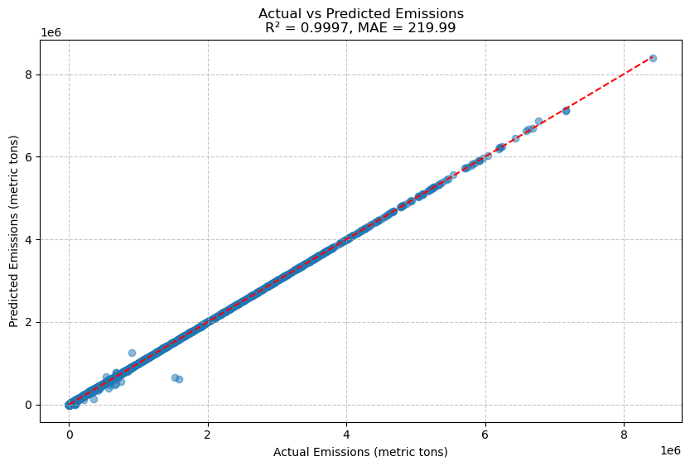
Figure 19: Actual & Predicted Emissions
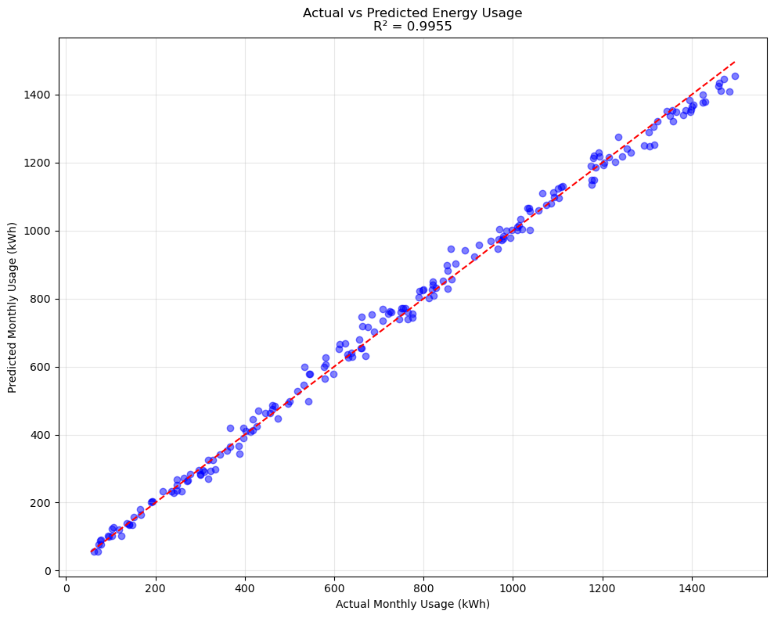
Figure 20: Actual & Predicted Energy Usage
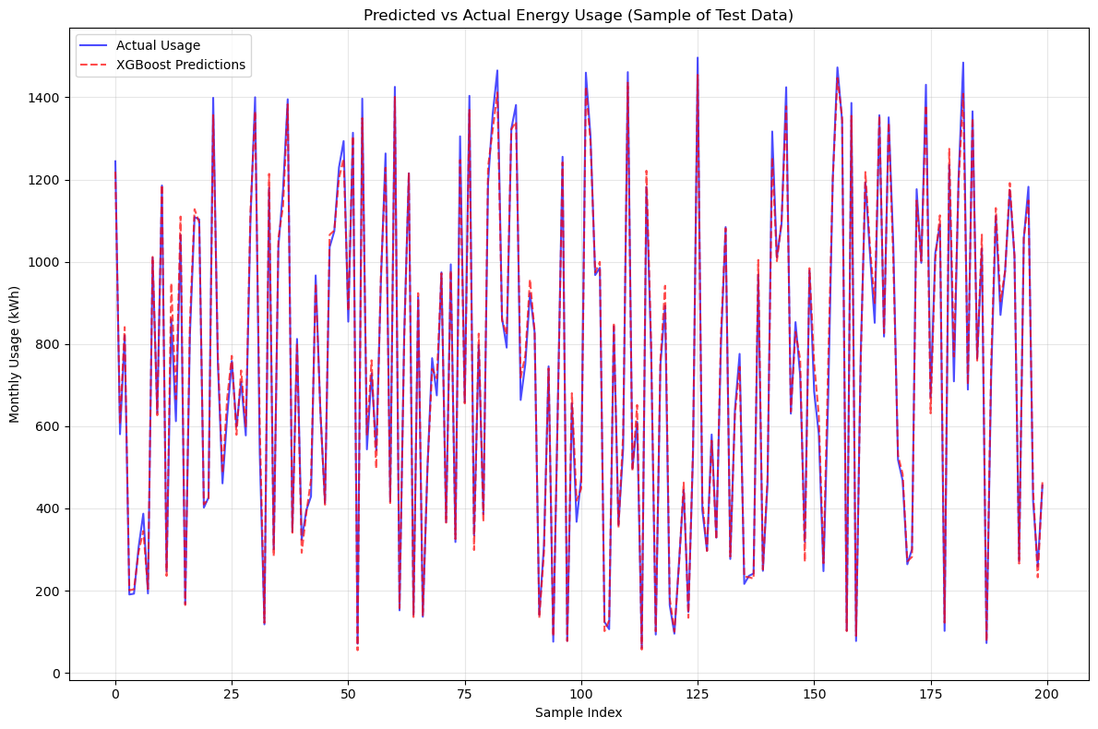
Figure 21: Predicted & Actual Energy Usage Sample Test
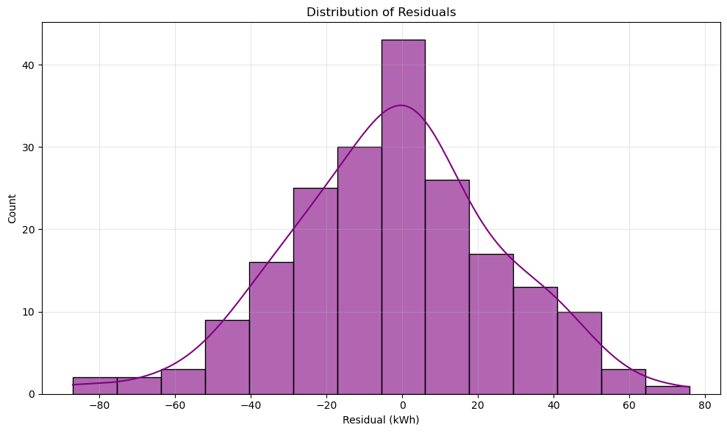
Figure 22: Residual Distribution of Energy Usage
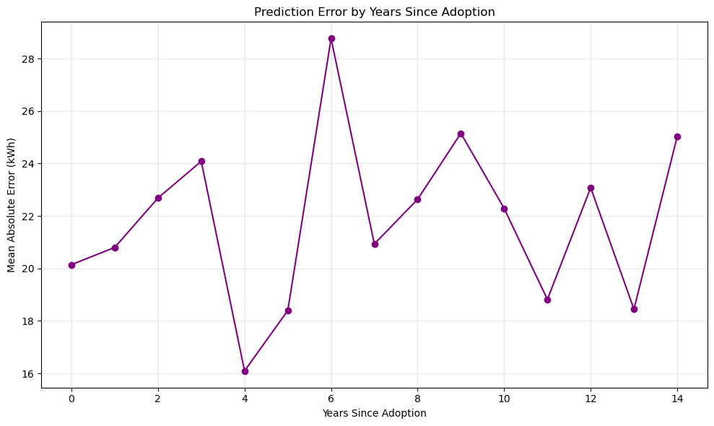
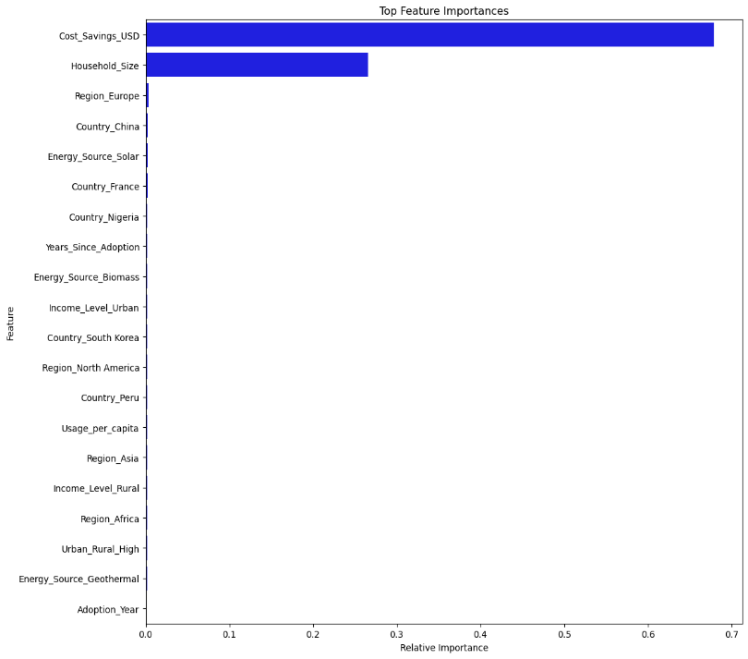
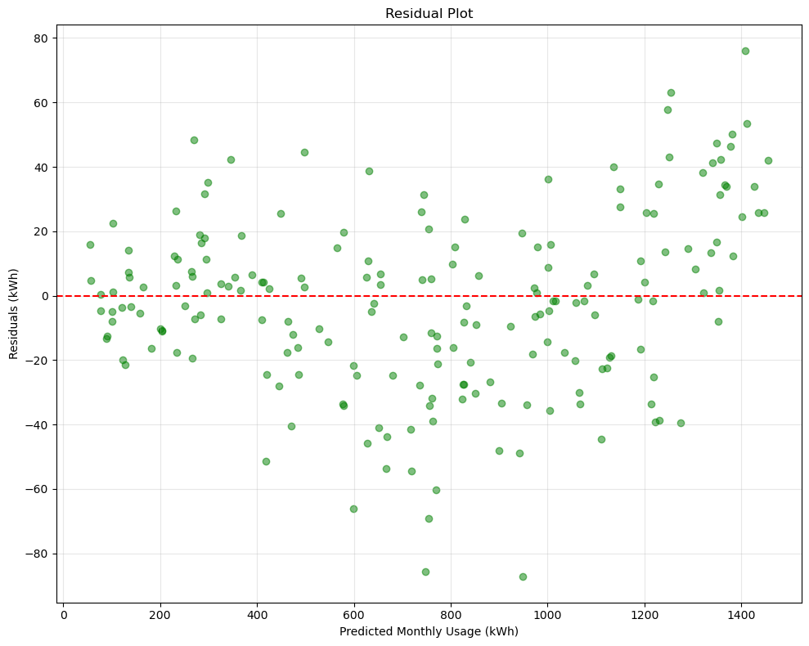
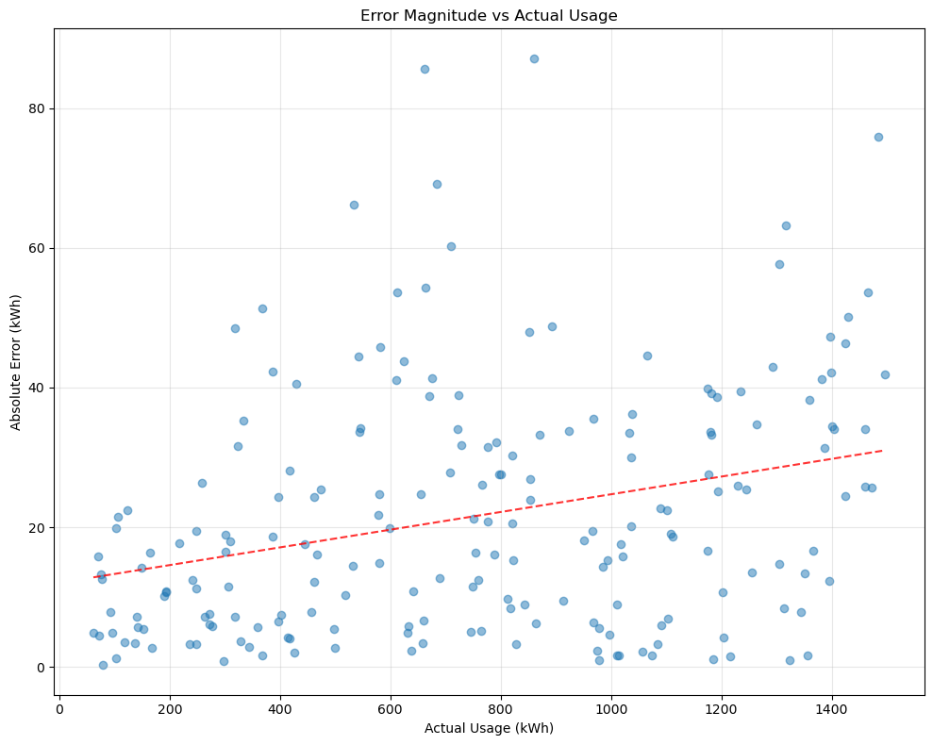
Figure 23: Residual Plot of Monthly Energy Usage Figure 24: Absolute Error & Actual Usage
Figure 25: Prediction Error since Adoption Figure 26: Feature Importance of Energy

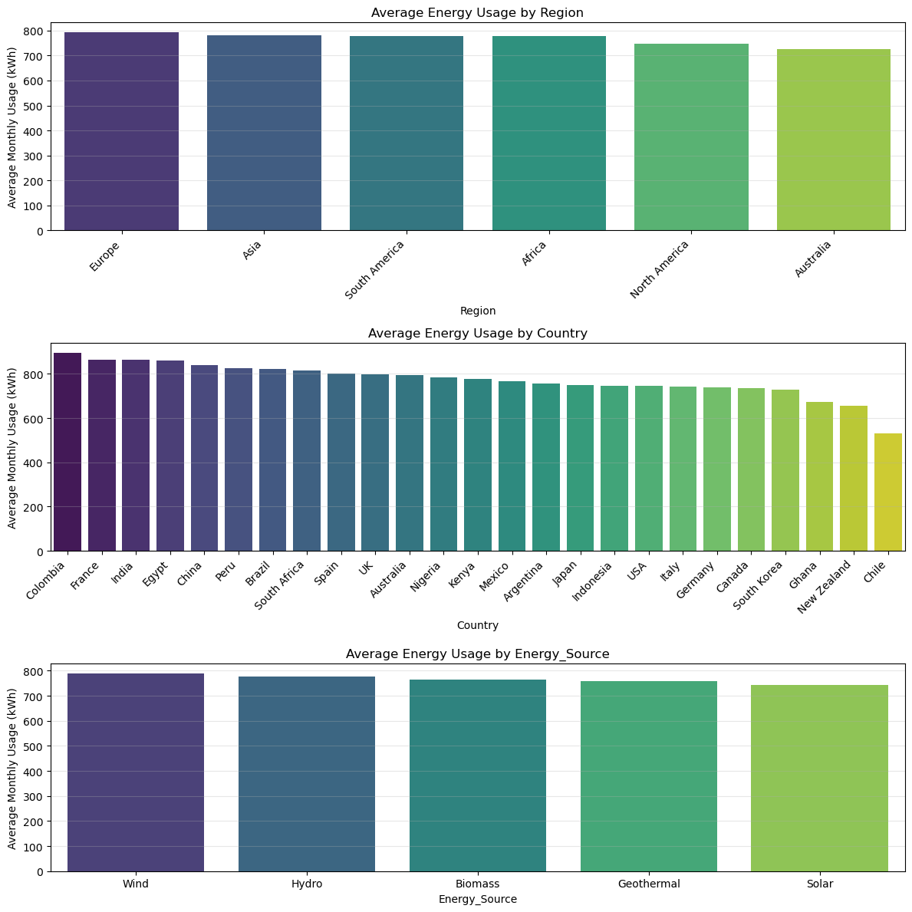
Figure 27: Average Energy Usage by Region, Country and via Energy Source

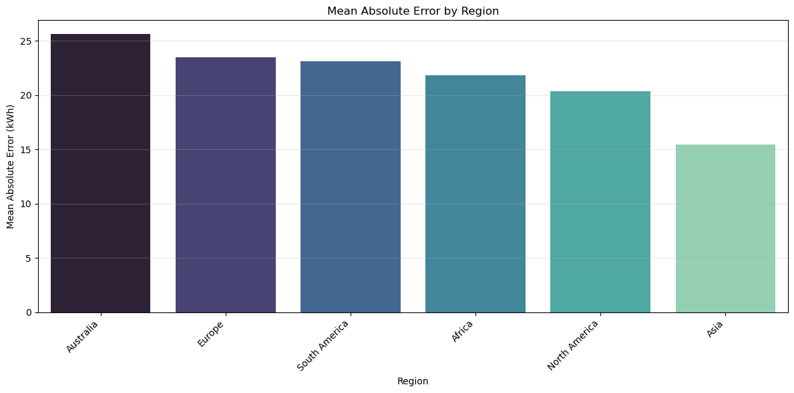
Figure 28: Mean Absolute Error by Region
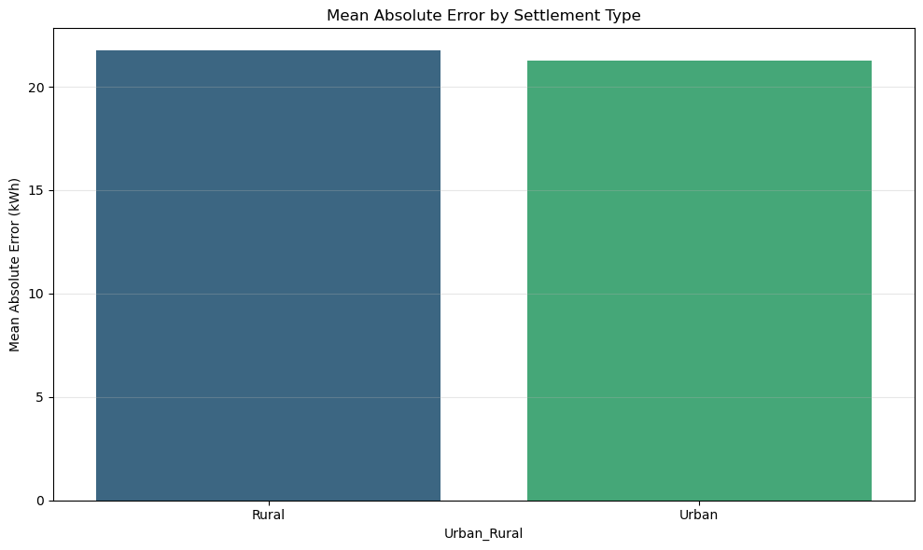
Figure 29: Mean Absolute Error based on Settlement Type

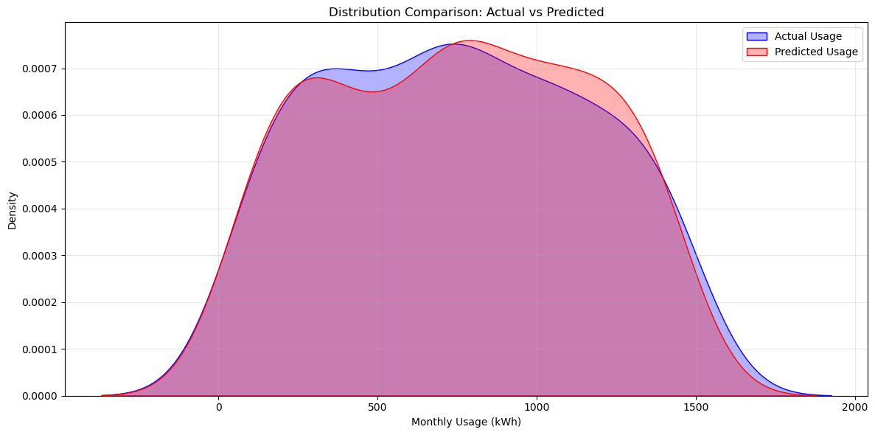
Figure 30: Distribution of Predicted & Actual Usage
- Computational Challenges
Computational challenges that arose when creating the model were the sizes of the datasets being large, causing the cost of computation to be extremely heavy when building the model and taking almost 30 to 45 minutes running the model tests with the total being almost 2.5 hours just trying to get one result of a model then another 1.5 hours to get the tuned and optimized model. Overall, some of the strengths are having our data fully cleaned and checked out to make sure that nothing is wrong. With the random forest, multiple iterations can be given through each feature to make sure that it is as good as possible when it comes to predicting.
- Ethical Considerations
To ensure privacy when collecting datasets, the identification and location of the observations is removed to ensure the safety of the observers. In terms of bias and fairness, different regions of the United States were selected to ensure that predicting temperature is not completely biased. An ethical consideration that was deeply thought about was the readings of the temperature being completely off when there was rain on certain days, meaning that they might not follow the randomness for our linear/polynomial regression model. Another ethical consideration that was thought about was the fluctuation in temperature and weather; there can be cases where there is a rapid and unpredictable change in weather conditions. A limitation that was experienced throughout this project was the constraints of the data quality, websites often want their users to pay for their datasets as it can be quite large and the quality in those datasets are quite high but there were other companies that had weather datasets available for free and had high quality. Another limitation would be the model assumptions since as linear/polynomial regression models are being used to predict temperature, it would assume that temperature and other variables would have a linear/polynomial relationship even though there is much more to it than that.
- Reflections
Upon reflection, an equation can be made that is properly able to predict data and other forms of yearly predictions since the amount of renewable energy and also temperatures continue to change. This would be optimal for many regions and if you are able to access current forecasts from satellites as it could be much more effective when it comes to implementing a new method.
Sources:
[1] European Parliament, “Climate change: the greenhouse gases causing global warming,” www.europarl.europa.eu, Mar. 23, 2023. https://www.europarl.europa.eu/topics/en/article/20230316STO77629/climate-change-the-greenhouse-gases-causing-global-warming
[2] Climate.gov, “History of Earth’s temperature since 1880 | NOAA Climate.gov,” Climate.gov, 2015. https://www.climate.gov/news-features/videos/history-earths-temperature-1880
[3] NASA, “World of Change: Global Temperatures,” Earth Observatory, 2023. https://earthobservatory.nasa.gov/world-of-change/global-temperatures
[4] United States Environmental Protection Agency, “Overview of greenhouse gases,” US EPA, Apr. 11, 2024. https://www.epa.gov/ghgemissions/overview-greenhouse-gases
[5] I. Tiseo, “GHG emissions in major economies 2000-2022,” Statista, Jan. 15, 2025. https://www.statista.com/statistics/1379208/annual-global-greenhouse-gas-emissions-selected-countries/

